**PubHub**

Configuration Document

Table of Contents

Table of Contents 2

1. Importing the Starter Kit into Eclipse 3

2. Importing the Database 7

3. Deploying the Starter Kit 11

# 1. Importing the Starter Kit into Eclipse

1. Download the starter kit from the task page
2. Open Eclipse to the desired workspace
3. Right-click the Package Explorer, and select “Import” -> “Import…”

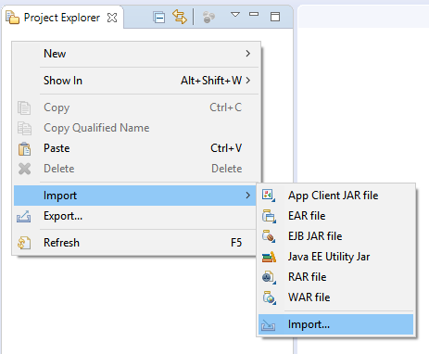

1. In the Import Wizard, search for and select “Projects from Folder or Archive.” Then, click next.

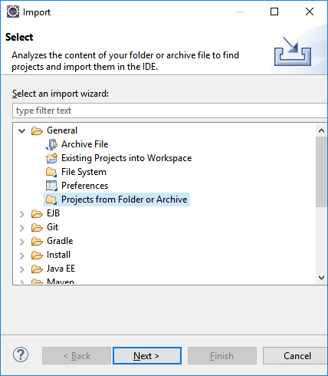

1. In the “Import Projects from File System or Archive” window, uncheck the “Detect and configure project natures” box. Then click the “Directory” button and select the root directory of the starter kit. Finally, click “Finish.”

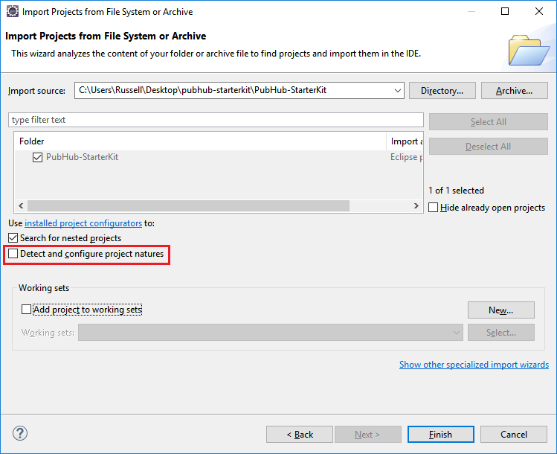

1. You should now have the Starter Kit added to your package explorer.
2. Open com.examples.pubhub.dao.DAOUtilities.java, and change the CONNECTION_PASSWORD and CONNECTION_USERNAME variables to match your PostgreSQL Database login information.

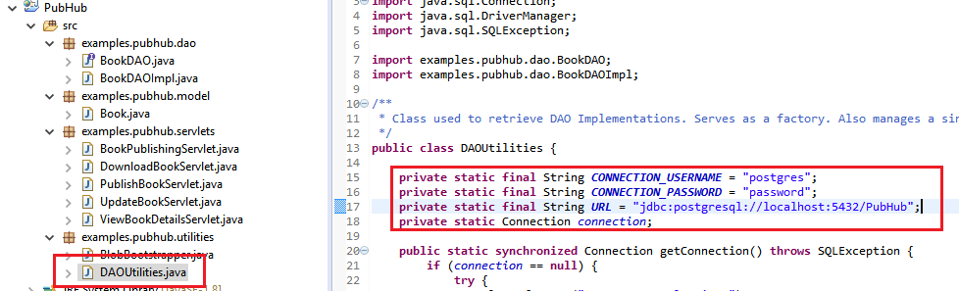

1. Lastly, right-click your project and select “Build Path”, then select “Configure Build Path…”
2. Click “Add Library”

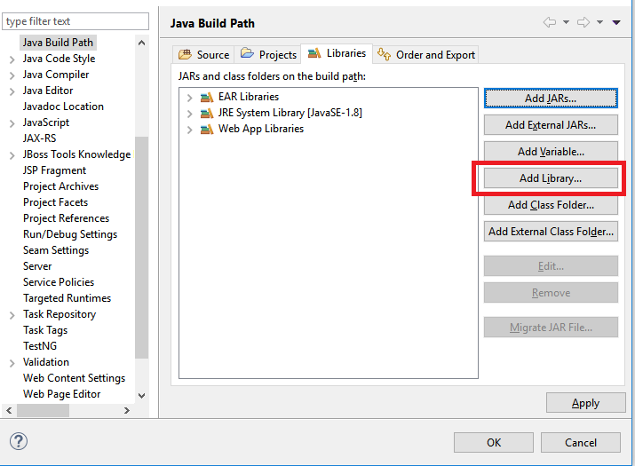

1. Select “Server Runtime” and click “Next”

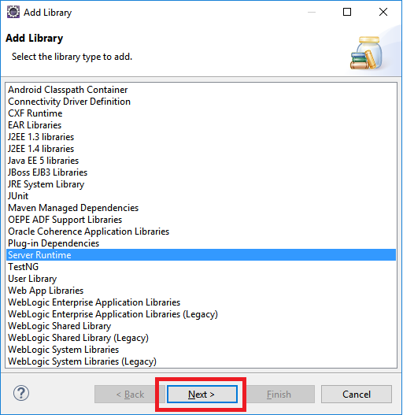

1. Select your WildFly runtime, and click “Finish”

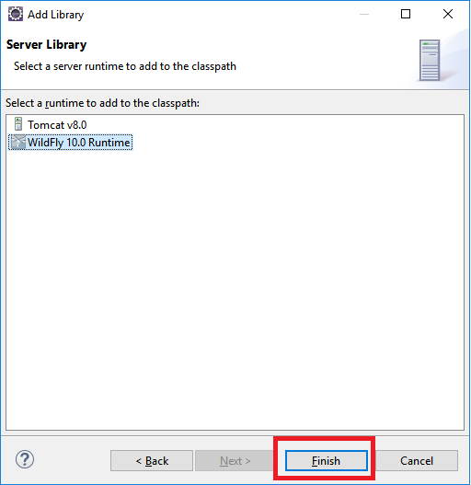

1. On the Java Build Path window, click “Ok”

# 2. Importing the Database

1. Open PgAdmin, and expand your PostgreSQL database

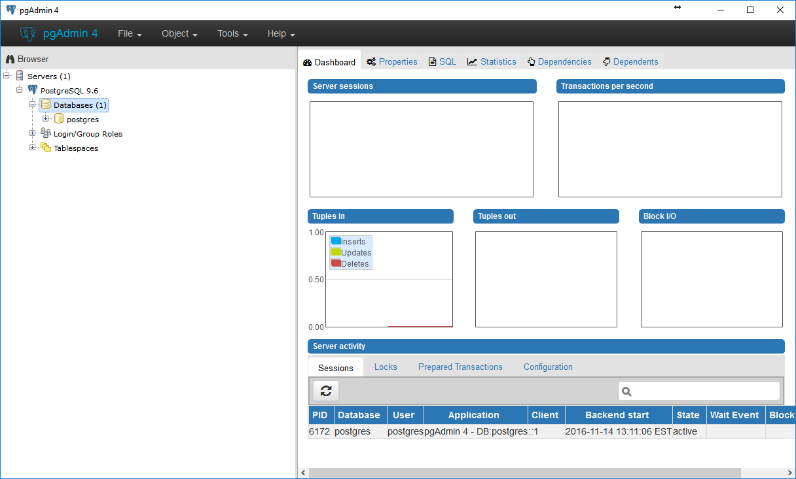

1. Right-click “Databases,” and select “Create” -> “Database…” Name it “PubHub.”

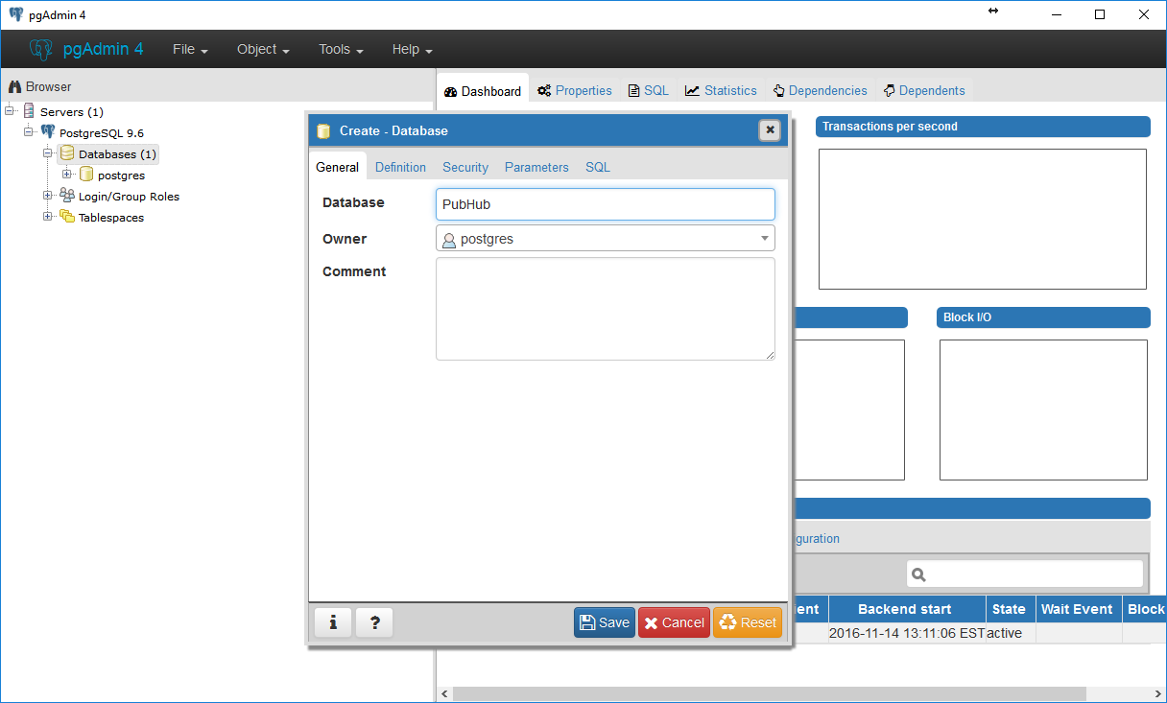

1. Click “Save.” This operation might take a few seconds. Then, right-click your new database, and select “Query Tool…”:

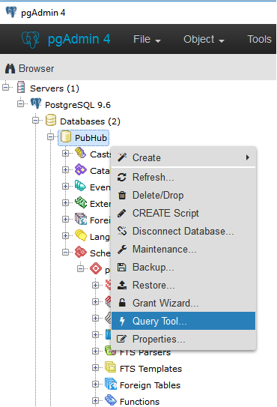

1. In the new SQL query window, open the SQL script located at “*...\<project template>\database_files\pubhub-setup.sql*”

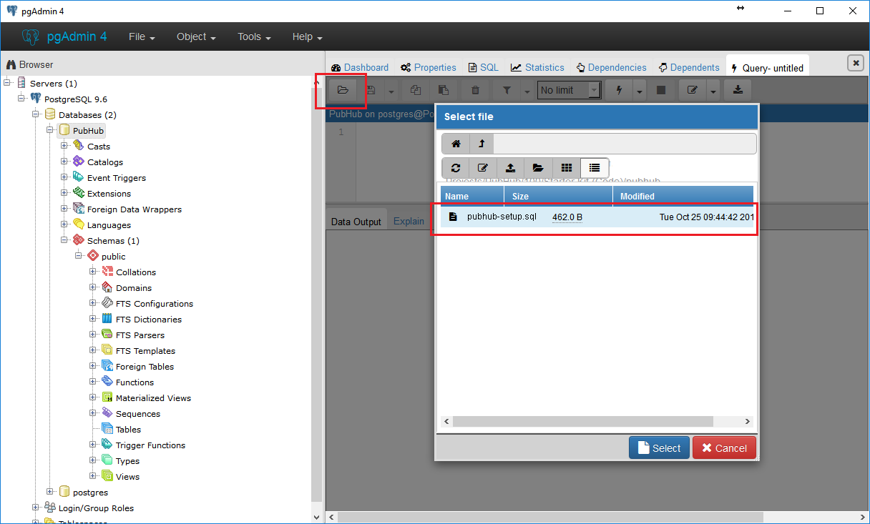

1. Click the lightning bolt button or hit F5 to execute the query:

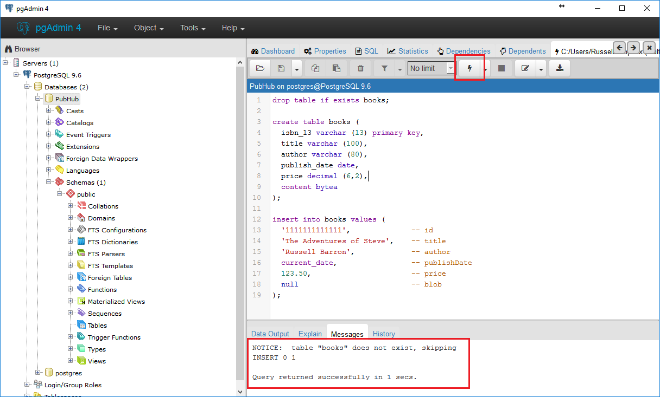

1. Verify that the script has successfully created the tables and inserted some appropriate dummy data:

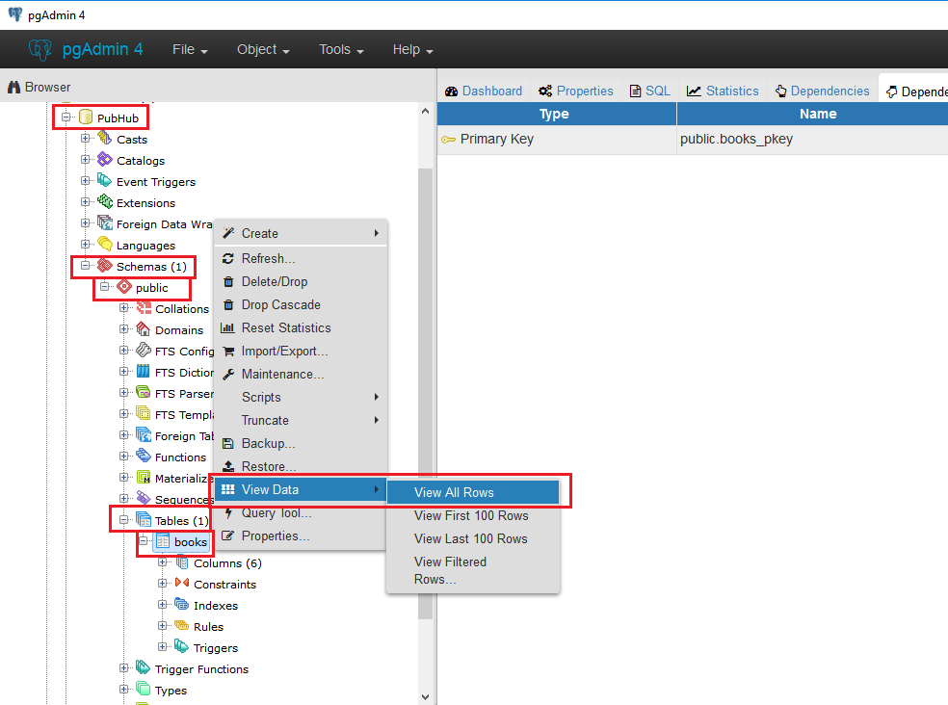

1. In Eclipse, execute examples.pubhub.utilities.BlobBootstrapper.java

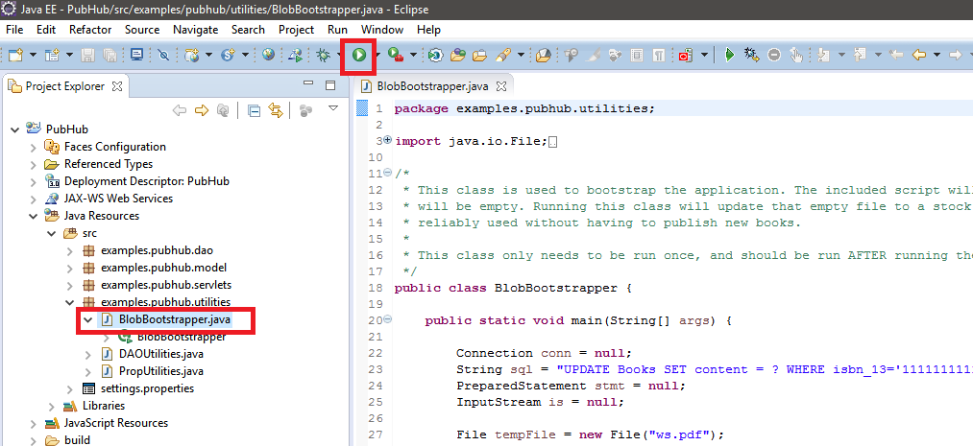

This will upload ws.pdf into the dummy data you uploaded with the provided script.

# 3. Deploying the Starter Kit

1. Right-click your server, then select “Add and Remove…”

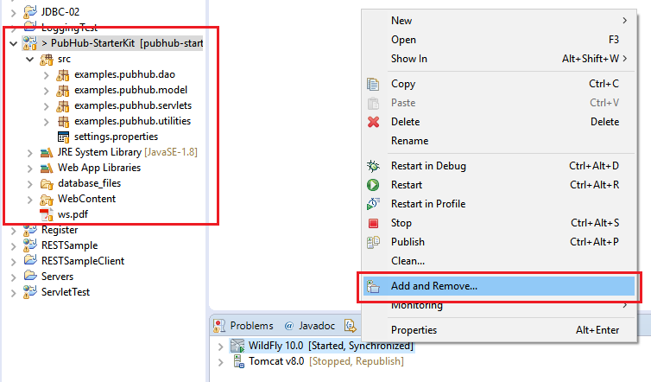

1. Add the PubHub project, then click ok. If your server is currently running, you may have to restart it for the application to properly deploy.

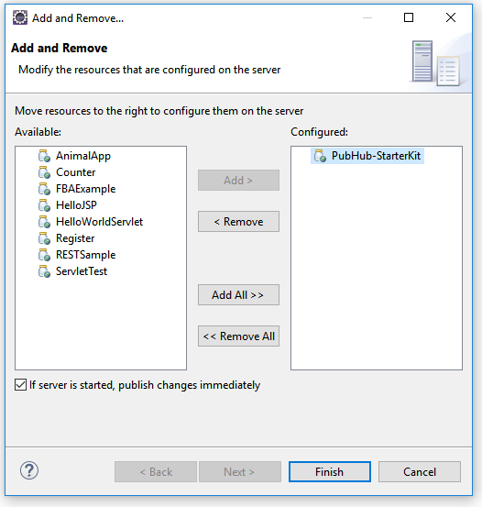

1. Right-click your application server again, and select “Start.” If you make any further changes to your application, you will need to restart the application server.

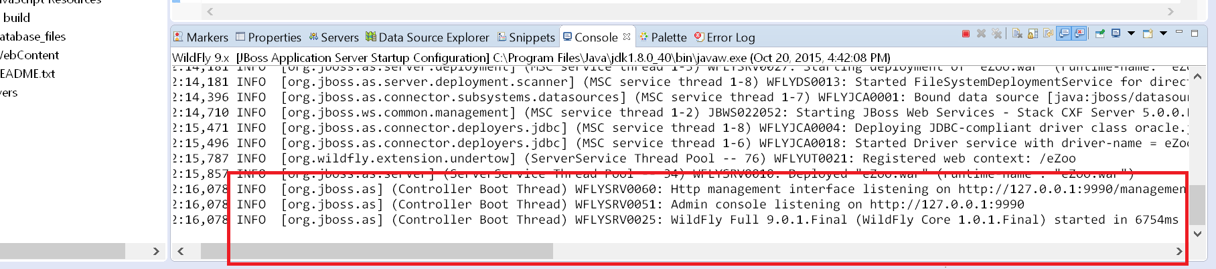

1. Congratulations! Your starter kit has been set up on your local machine, and you are free to make changes as per your project requirements. You can access the Starter Kit by opening any web browser and navigating to <http://localhost:8080/PubHub>. Any changes you make to your application may require you to restart your application server to take effect.